(Logos – School District and Local Law Enforcement)

E-bike Registration Application

In compliance with school policies promoting safety, students are prohibited from bringing any illegal device onto campus. This includes any e-wheel device that is considered illegal per California Vehicle Codes (CVC). Effective [date], students will only be permitted to park their e-bike (e-scooters) on campus with an approved registration showing their device complies with California laws. Please complete the following application requesting permission for your student to park their e-bike on campus.

For the “e-wheel” to be legal, it must:
- Have a Class 1, 2, or 3 label visibly affixed to the e-bike
- Have a maximum 750 watt motor
- Have a maximum speed of 20 mph on motor power alone (Class 2)
- Be age legal; a student must be 16 years old to ride an e-scooter (with a driver's license) or a Class 3 e-bike (no license required).

Student’s Name: _____________________ Age: __________

School: ______________________________________

E-device Brand and Model: ___________________________________

Class label (must be visible on e-bike): _________________ (Class I, 2, or 3)

Motor Size (wattage): _______________________ (maximum 750)

Maximum motor-assisted speed in the fasted mode or class: _______________mph

To complete the application, please attach a copy of the manufacturer’s website page that identifies the motor size and top motor-assisted speed in the fastest mode/class. The below S and R Series device, taken from the manufacture’s webpage, shows it is not legal because its “off-road” mode exceeds CVC requirements for an e-bike.
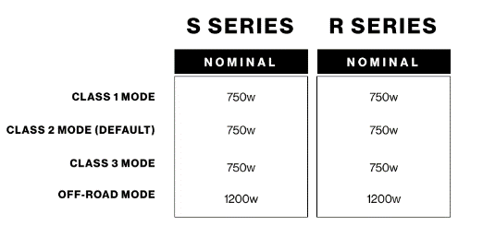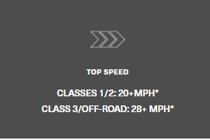

I CERTIFY THAT THIS INFORMATION IS CORRECT:

Parent/Guardian’s Name: __________________________

Parent/Guardian’s Signature (if student is under 18): ____________________________

Student Signature (18 or older) _______________________________

