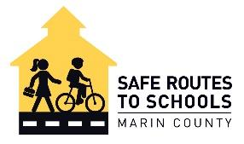
mbb

Dear Parents -
The middle school years are an exciting time of exploration and independence.
Middle school students typically enjoy their increased freedom of walking or biking to school together with friends, and morning exercise helps to reduce stress and increase academic alertness. Please support your student’s resiliency and promote safer streets by having your student walk, bike, carpool or ride the bus this year.
Safety is our mutual priority. Please plan accordingly by selecting and practicing the suggested routes to school with your student. Recommended route maps are available on our website for most schools in our county.
A special note about E-bikes and E-Scooters: An e-bike can be a great solution for long commutes and heavy backpacks but only if your student has prior experience with cycling. E-bikes are heavier and go twice as fast as conventional bikes for students of this age; riders must have the confidence, skill, and maturity to responsibly ride on the street and on multi-use pathways.
Parents are legally and financially responsible for children under 18 years of age. Please pay extra attention to the laws that govern the use of e-bikes and e-scooters; for the safety of your student and others, illegal devices are not permitted on roads, pathways, and public grounds.
For the e-wheel to be legal, it must:
- Have a Class 1, 2, or 3 label visibly affixed to the e-bike
- Have a maximum 750-watt motor
- Have a maximum speed of 20 mph on motor power alone (Class 2)
- Be age-legal; a student must be 16 years old to ride an e-scooter (with a driver's license) or a Class 3 e-bike (no license required).

Again, thank you for encouraging your student to choose a safe and healthy commute to school next fall. We look forward to meeting your child in our Safe Routes to Schools’ sixth-grade bike classes this year.

Gwen Froh
Program Director, Safe Routes to Schools
Gwen@marinbike.org
saferoutestoschools.org

